**Assignment 4**

**Q = i , ii , iii , iv , v , vi**

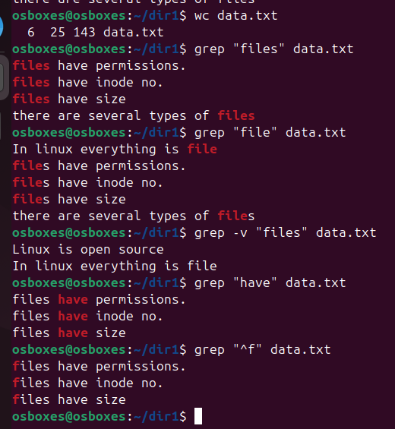

**Q = vii , viii , ix**

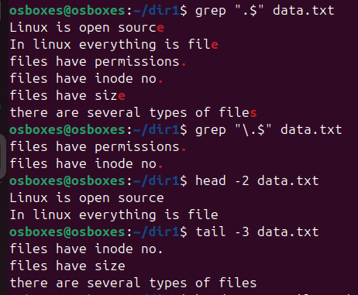

**Q = x**

